**SUMMER TRAINING PROJECT**

On

BLOCKCHAIN TECHNOLOGY

(CryptHotel)

**Bachelor of Technology**

Of

**Dr. Akhilesh Das Gupta Institute of Technology and Management**

**Session 2018-19**



Supervised by:

**Ms. Uma Tomar Malik**  Submitted by: Kshitij Tripathi

Roll no.- 03715602716

Acknowledgement

It is my proud privilege to release the feeling of gratitude who helped me finish this project with extreme efficiency and resourcefulness. I’d like to thank my college faculty, especially Dr. Saurabh Gupta and Ms. Uma Tomar for their guidance and inspiration which led to the making of this project.

I’d also like to thank my friends who gave valuable input to the ideas for this project.

I also thank the Director of Dr. Akhilesh Das Gupta Institute of Technology and Management, Prof. (Dr.) Sanjay Kumar for providing us an opportunity to embark on this project.

Submitted by: Kshitij Tripathi

Roll no.- 03715602716

Class: CSE- T1

Chapter 1

# CryptoCurrency

A cryptocurrency is a digital or virtual currency that uses cryptography for security. A cryptocurrency is difficult to counterfeit because of this security feature. A defining feature of a cryptocurrency, and arguably its most endearing allure, is its organic nature; it is not issued by any central authority, rendering it theoretically immune to government interference or manipulation.

The first cryptocurrency to capture the public imagination was Bitcoin, which was launched in 2009 by an individual or group known under the pseudonym Satoshi Nakamoto. As of May 2018, there were over 17 million bitcoins in circulation with a total market value of over $140 billion. Bitcoin's success has spawned a number of competing cryptocurrencies, such as Litecoin, Namecoin and PPCoin.

## Cryptocurrency Benefits and Drawbacks

Cryptocurrencies make it easier to transfer funds between two parties in a transaction; these [transfers](https://www.investopedia.com/terms/t/transfer.asp) are facilitated through the use of public and private keys for security purposes. These fund transfers are done with minimal processing fees, allowing users to avoid the steep fees charged by most banks and [financial institutions](https://www.investopedia.com/terms/f/financialinstitution.asp) for [wire transfers](https://www.investopedia.com/terms/w/wiretransfer.asp).

Central to the appeal and function of Bitcoin is the [blockchain](https://www.investopedia.com/terms/b/blockchain.asp) technology it uses to store an online ledger of all the transactions that have ever been conducted using bitcoins, providing a data structure for this ledger that is exposed to a limited threat from hackers and can be copied across all computers running Bitcoin software. Every new block generated must be verified by the ledgers of each user on the market, making it almost impossible to forge transaction histories. Many experts see this blockchain as having important uses in technologies, such as online voting and crowdfunding, and major financial institutions such as JP Morgan Chase see potential in cryptocurrencies to lower transaction costs by making payment processing more efficient.

However, because cryptocurrencies are virtual and do not have a central repository, a digital cryptocurrency balance can be wiped out by a computer crash if a backup copy of the [holdings](https://www.investopedia.com/terms/h/holdings.asp) does not exist. Since prices are based on supply and demand, the rate at which a cryptocurrency can be exchanged for another currency can fluctuate widely.

The anonymous nature of cryptocurrency transactions makes them well-suited for a host of nefarious activities, such as [money laundering](https://www.investopedia.com/terms/m/moneylaundering.asp) and [tax evasion](https://www.investopedia.com/terms/t/taxevasion.asp). However, cryptocurrency advocates often value the anonymity highly. Cryptocurrencies are also considered by some economists to be a short-lived fad or speculative bubble - concerned especially that the currency units, such as Bitcoins, are not rooted in any material goods. Bitcoin has indeed experienced some rapid surges and collapses in value.

Cryptocurrencies are not immune to the threat of hacking. In Bitcoin's short history, the company has been subject to over 40 thefts, including a few that exceeded $1 million in value. Still, many observers look at cryptocurrencies as hope that a currency can exist that preserves value, facilitates exchange, is more transportable than hard metals, and is outside the influence of central banks and governments.

## Ethereum

Like Bitcoin, Ethereum is a distributed public blockchain network. Although there are some significant technical differences between the two, the most important distinction to note is that Bitcoin and Ethereum differ substantially in purpose and capability. Bitcoin offers one particular application of blockchain technology, a peer to peer electronic cash system that enables online Bitcoin payments. While the Bitcoin blockchain is used to track ownership of digital currency (bitcoins), the Ethereum blockchain focuses on running the programming code of any decentralized application.

In the Ethereum blockchain, instead of mining for bitcoin, miners work to earn Ether, a type of crypto token that fuels the network. Beyond a tradeable [cryptocurrency](http://blockgeeks.com/guides/what-is-cryptocurrency-everything-you-need-to-know-ultimate-guide/), Ether is also used by application developers to pay for transaction fees and services on the Ethereum network.

There is a second type of token that is used to pay miners fees for including transactions in their block, it is called gas, and every smart contract execution requires a certain amount of gas to be sent along with it to entice miners to put it in the blockchain.

## **What is a smart contract?**

[Smart contract](http://blockgeeks.com/guides/smart-contracts-the-blockchain-technology-that-will-replace-lawyers/) is just a phrase used to describe computer code that can facilitate the exchange of money, content, property, shares, or anything of value. When running on the blockchain a smart contract becomes like a self-operating computer program that automatically executes when specific conditions are met. Because smart contracts run on the blockchain, they run exactly as programmed without any possibility of censorship, downtime, fraud or third-party interference.

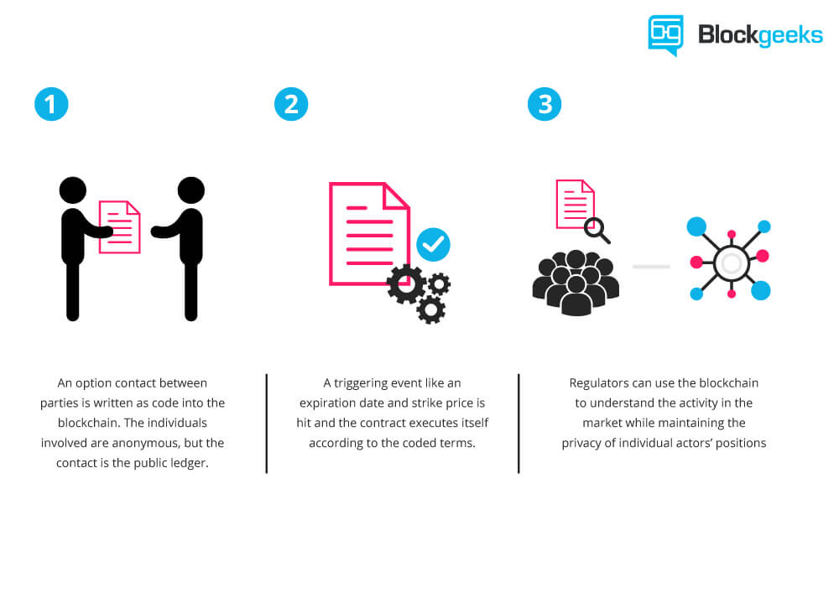

While all blockchains have the ability to process code, most are severely limited. Ethereum is different. Rather than giving a set of limited operations, Ethereum allows developers to create whatever operations they want. This means developers can build thousands of different applications that go way beyond anything we have seen before.

## **What can Ethereum be used for?**

Ethereum enables developers to build and deploy decentralized applications. A [decentralized application](https://blockgeeks.com/guides/dapps-the-decentralized-future/) or Dapp serve some particular purpose to its users. Bitcoin, for example, is a Dapp that provides its users with a peer to peer electronic cash system that enables online Bitcoin payments. Because decentralized applications are made up of code that runs on a blockchain network, they are not controlled by any individual or central entity.

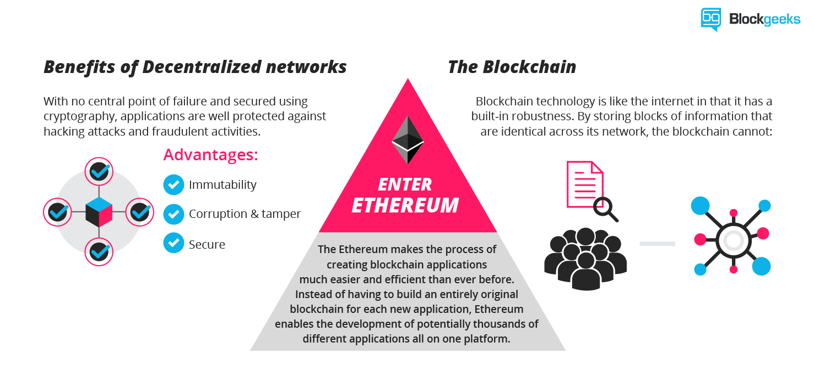

Any services that are centralized can be decentralized using Ethereum. Think about all the intermediary services that exist across hundreds of different industries. From obvious services like loans provided by banks to intermediary services rarely thought about by most people like title registries, voting systems, regulatory compliance and much more.

Ethereum can also be used to build Decentralized Autonomous Organizations (DAO). A DAO is fully autonomous, decentralized organization with no single leader. DAO’s are run by programming code, on a collection of smart contracts written on the Ethereum blockchain. The code is designed to replace the rules and structure of a traditional organization, eliminating the need for people and centralized control. A DAO is owned by everyone who purchases tokens, but instead of each token equating to equity shares & ownership, tokens act as contributions that give people voting rights.

## **What are the benefits of Ethereum decentralized Platform?**

Because decentralized applications run on the blockchain, they benefit from all of its properties.

* Immutability – A third party cannot make any changes to data.
* Corruption & tamper proof – Apps are based on a network formed around the principle of consensus, making censorship impossible.
* Secure – With no central point of failure and secured using cryptography, applications are well protected against hacking attacks and fraudulent activities.
* Zero downtime – Apps never go down and can never be switched off.

Chapter 2

# CryptHotel

CryptHotel is a decentralized app for hotel reservation, using Ethereum as its base payment option.

A DApp, is an app that runs on the Ethereum blockchain. Each instance of a DApp has its own blockchain and each node of a blockchain is called a block. The DApp interacts with the Ethereum Chain using smart contracts created by us. Each smart contract needs to be compiled, deployed and executed before the contract becomes a part of the blockchain.

In CryptHotel, each hotel that exists in our network exists as a separate block on the CryptHotel blockchain. The idea is to make it easier for people to reserve hotel suites using simple and efficient smart contracts. The website aims to make the DApp appealing and understandable to users.

Our aim is to ensure that only the best suites are delivered to our customers and thus, we have no option of choosing a suite. In case of any inconvenience, we and the hotel will always be available to help out.

Since each hotel is on its own block, the customer can directly pay or interact with the block. Each transaction is secure and saved on both sides of the contract, i.e, with the user and the hotel, which provides a safety net and prevents malpractices of all kinds.

The implementation of this project is NOT based on BitCoin, which is banned by many countries but uses blockchain instead, which is a technology and an aspect of the Internet. Blockchain is secure, transparent and faster than existing technologies, which makes it perfect for such implementations.

The implementation takes place on a test network called Ganache, which is used to deploy contracts and web apps before deploying them on the actual blockchain. We are using MetaMask as a wallet for our transactions with our DApp. This DApp was built on the truffle framework, which enables us to work and test it in Ganache.

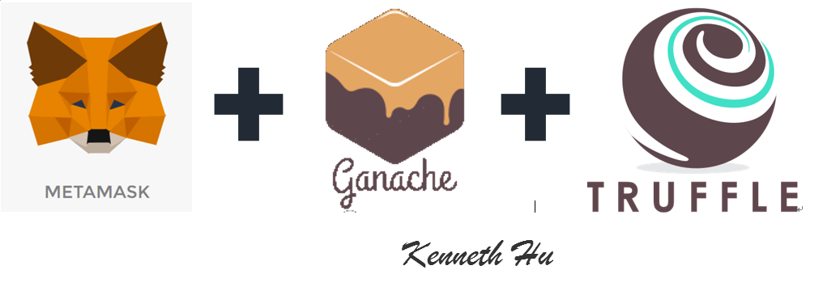

# Drawbacks of Existing Hotel Reservation Model

* The existing hotel reservation model is slow and inefficient.
* It enables middlemen to extract money from customers and hotels.
* It is not secure and is prone to hacks and exploits.
* It is not truly transparent.

# Benefits

* Eliminates middlemen from hassling both customers and hotels
* Middlemen meddle with the prices for both sides of the contract and try to earn maximum profit for themselves
* This project ensures direct payment to the hotels from the customers
* It makes the reservation process transparent to both sides of the transparent

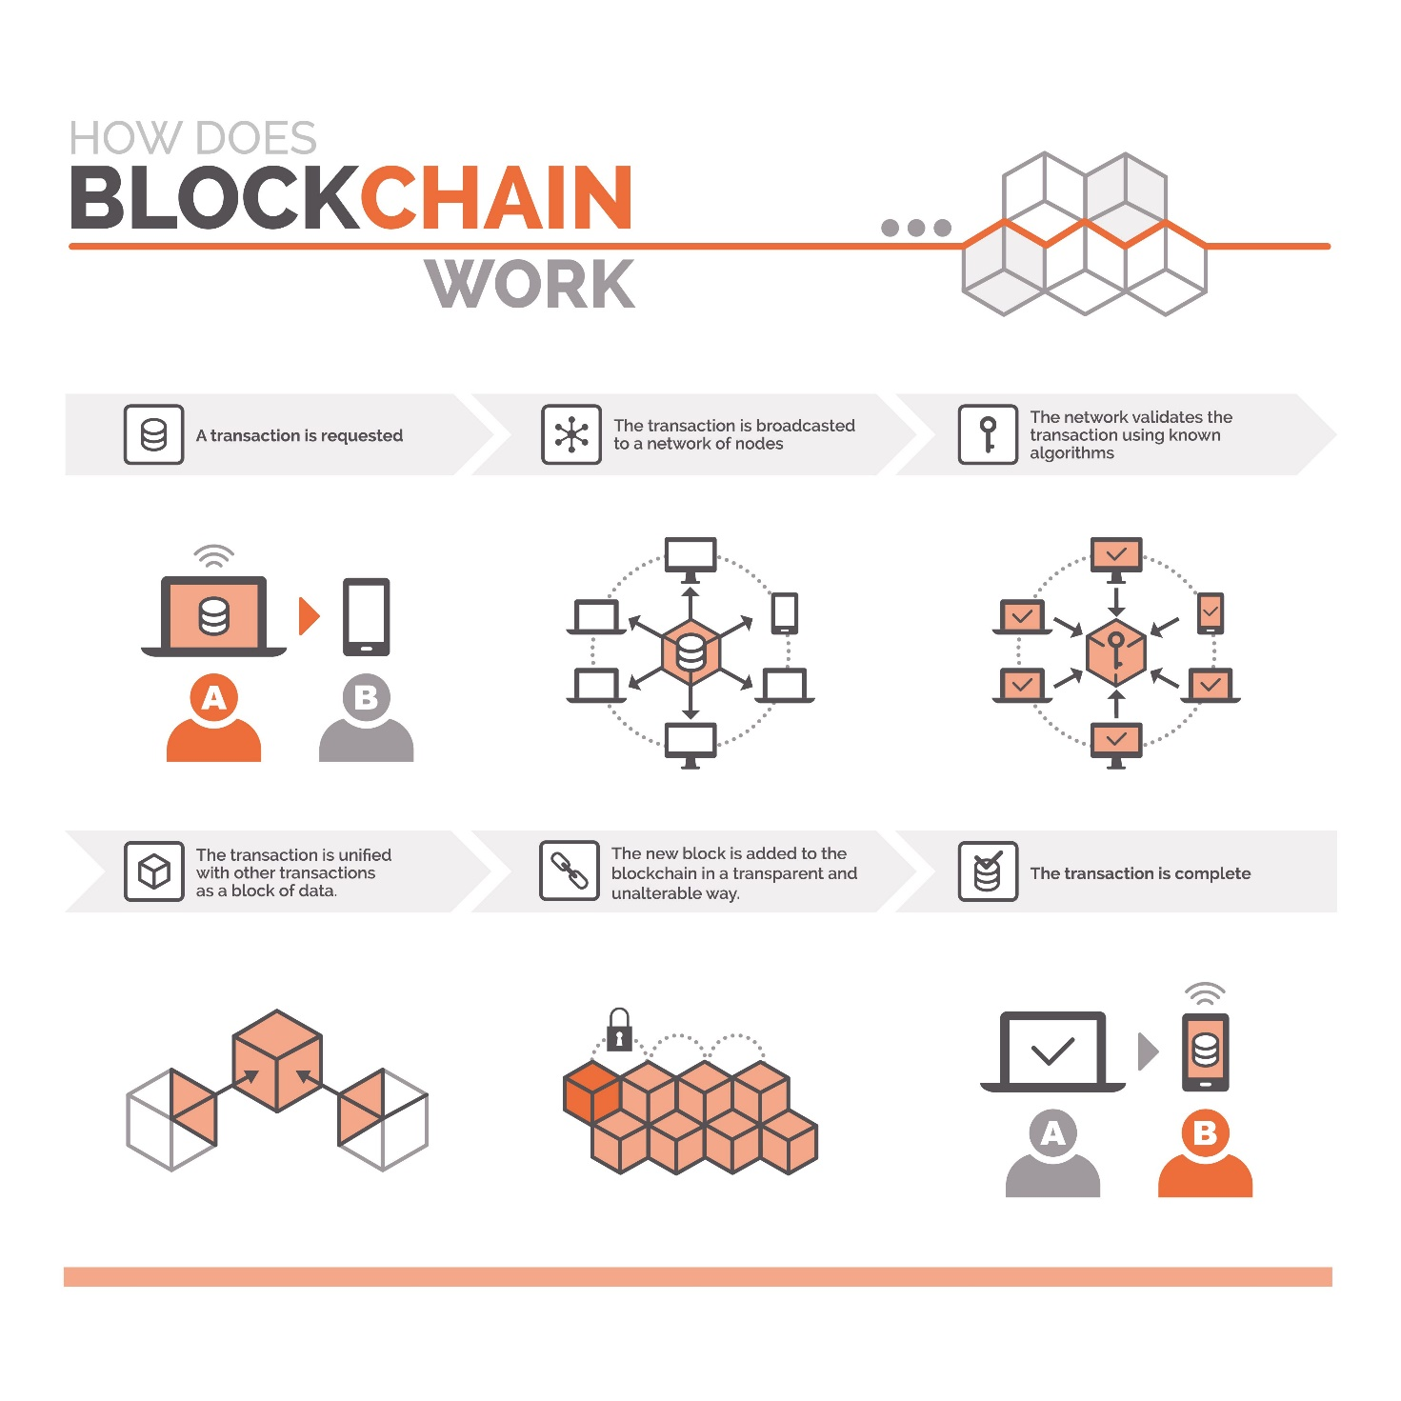

# Future Prospects

* We aim to create our own token for the transaction between customer and hotels
* We aim to add flights and cabs to our blockchain to increase travel efficiency for our customers
* Once the development is complete, we aim to launch an ICO with enough support to make this project a reality.
* This project changes the entire travel and economic industry.
* With the addition of other currencies we can make this a truly efficient solution to travel problems.

Chapter 3

# Result

In this section we provide working screenshots for our website and DApp, which has been deployed on a test network Ganache. The website shown has been built using HTML, CSS and JavaScript. Each element shown in the screenshots has either been made or inspired from open source projects only.

Bibliography

1. <https://truffleframework.com/docs/truffle/getting-started/truffle-with-metamask>
2. <https://truffleframework.com/docs/ganache/overview>
3. <https://metamask.io/>
4. <https://getbootstrap.com/docs/4.1/getting-started/introduction/>
5. <https://github.com/Gesundheit/CryptHotel>
6. <https://google.com>
7. <https://blockchainhub.net/decentralized-applications-dapps/>
8. https://blockgeeks.com/guides/ethereum/